INFORMATION MANAGEMENT
Exercise 9
1. List the minimum perks package.
SELECT MIN(perks) FROM employee_data;
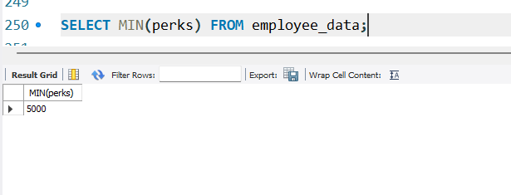

2. List the maximum salary given to a "Programmer".
SELECT MAX(salary) FROM employee_data WHERE title='Programmer';
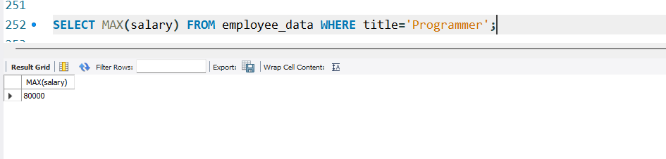
3. Display the age of the oldest “Marketing Executive”.
SELECT MAX(age) FROM employee_data WHERE title='Marketing Executive';
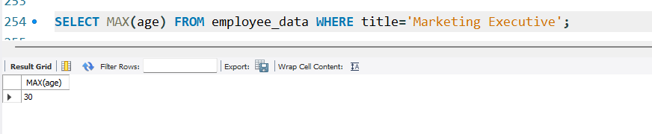

4. Find the first and last names of the oldest employee.
SELECT f_name, l_name FROM employee_data ORDER BY age DESC LIMIT 1;
